STRICTLY CONFIDENTIAL

Application Form for Mini-Pupillage

Candidate’s full name:
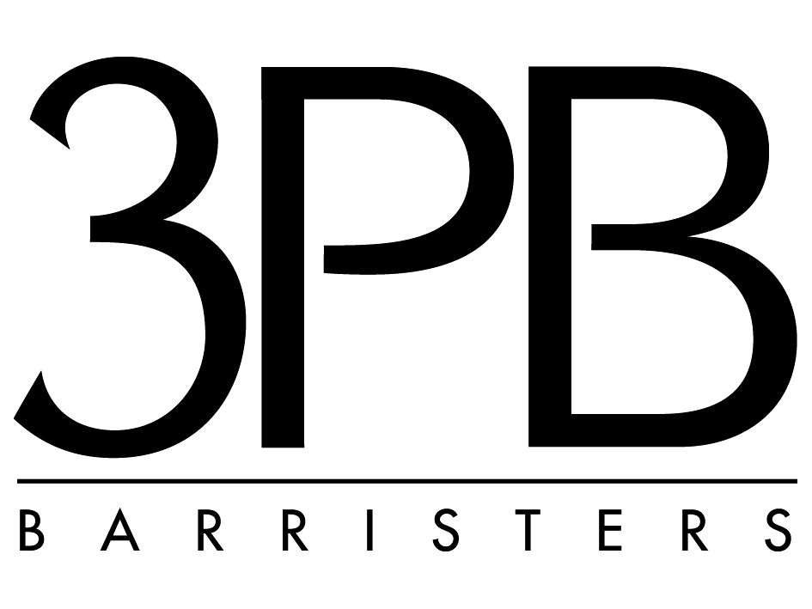

Centre to which you are applying:

3 PB’s Commitment to Equality and Diversity

3PB is committed to providing equal opportunity to applicants, staff, mini pupils, pupils and members, and to encouraging diversity in the workplace. We do not tolerate unlawful discrimination. We believe that treating people with dignity and respect is an important part of realising equal opportunities and diversity.

For Office Use Only

Date Received

Please return this form by email, marked for the attention of James Thornton, to Minipupils@3pb.co.uk, or by hard copy to Chambers of David Berkley QC, 3 Paper Buildings, Temple, London EC4Y 7EU.

In accordance with Fair Recruitment principles, Chambers does not accept applications by way of covering letter and CV, or application forms that simply refer to an attached CV.

For further information about mini pupillage, including our assessment criteria, please download our Mini-Pupillage Policy from the “Join Us” page of the 3PB website.

Personal Details
Address

Mobile number (or best contact number)

Email:

Secondary Education

Name of school or college Dates attended Qualifications and grades

Higher Education
Name of university/college Dates attended Qualifications/grades/class

Relevant achievements and work experience (paid or voluntary)
Use this box to set out your relevant achievements and experience, including paid or unpaid work experience, any leadership or project management experience, any awards that you have won, any mooting or advocacy that you have undertaken and whether you have completed any mini pupillages elsewhere.

More About You

What attracts you to a career at the Bar? (max 300 words)

Which areas of law particularly interest you? (max 300 words)

Why have you applied to 3PB? (max 300 words)

DECLARATION

I believe that the information that I have provided in this form is true. I understand that 3PB may in its discretion rescind any offer of mini pupillage to me or terminate any mini pupillage that is in progress if any information that I have provided is found to be misleading, materially incomplete or untrue.

I understand that 3PB will use this information for the purposes of processing my application form. I give my consent to the processing of my data and to use it for statistical information and reporting to the BSB and other regulators.

Signed (leave blank if emailing)

Print name

Date

